Pwnlab: Init

- Use netdiscover to locate the target machines IP
- Which is 10.10.10.8
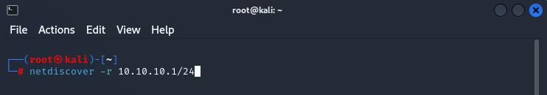
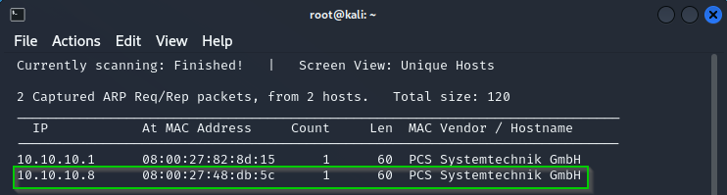

- Use nmap to scan the target IP
- Finding 4 open ports, including a http and MySQL tcp port
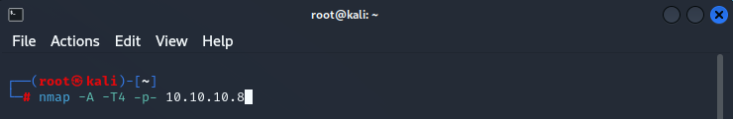
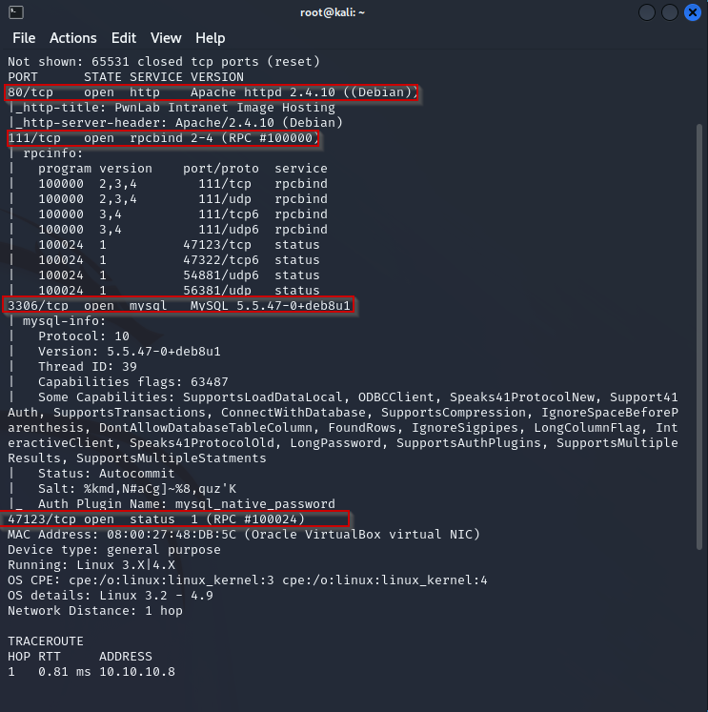

- Seeing port 80 open tells it might be a web application, which is correct
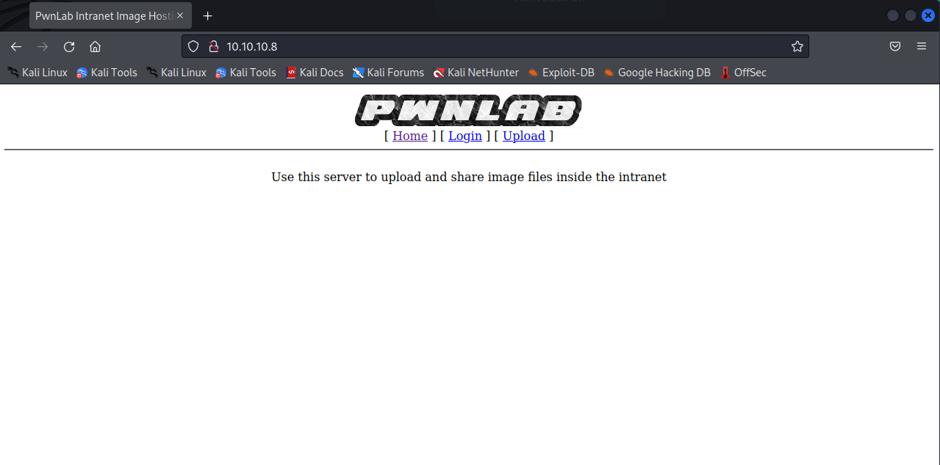

- Using “DirBuster”, we can see the various directories pwnlab contains
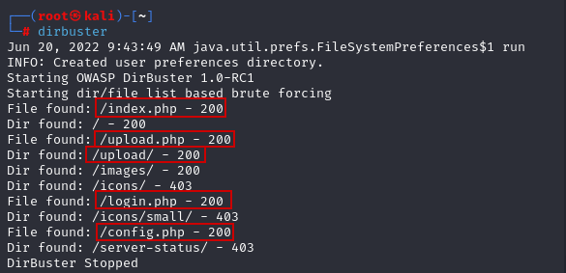

- An /upload/ tab hints that something malicious could be uploaded
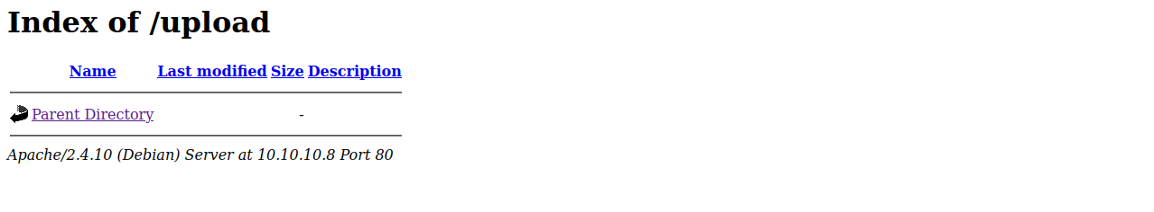

- Nikto Scan used to scan for potential known vulnerabilities
- php is being used and the config page could contain useful information
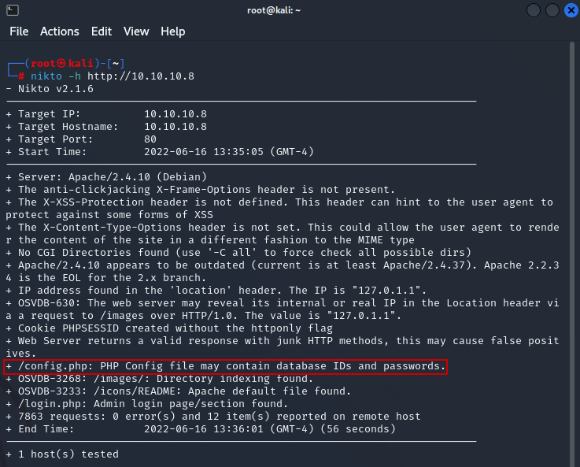

- Pwnlab is using a php filter
- So, a LFI vulnerability is used to bypass the config.php filter

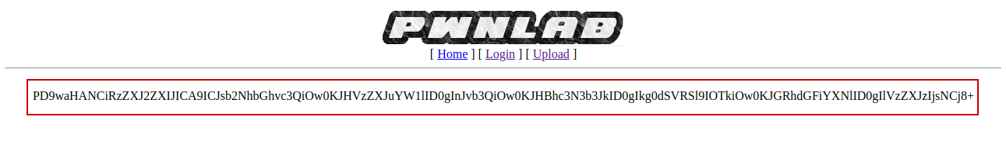

- Decoded base-64 content
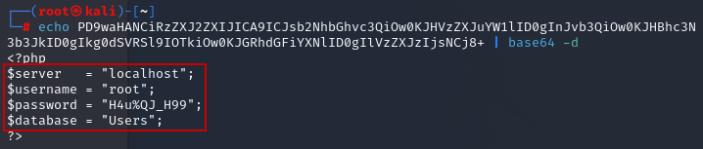

- Bypassing index.php filter
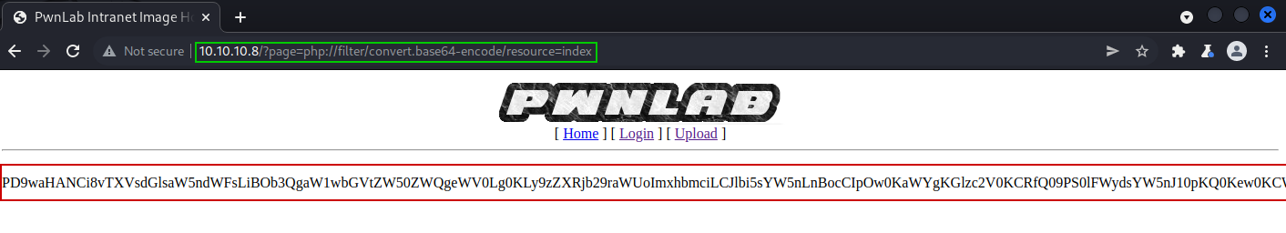

- Decoded base-64 content
- can see multilingual support is not implemented so this can be manipulated
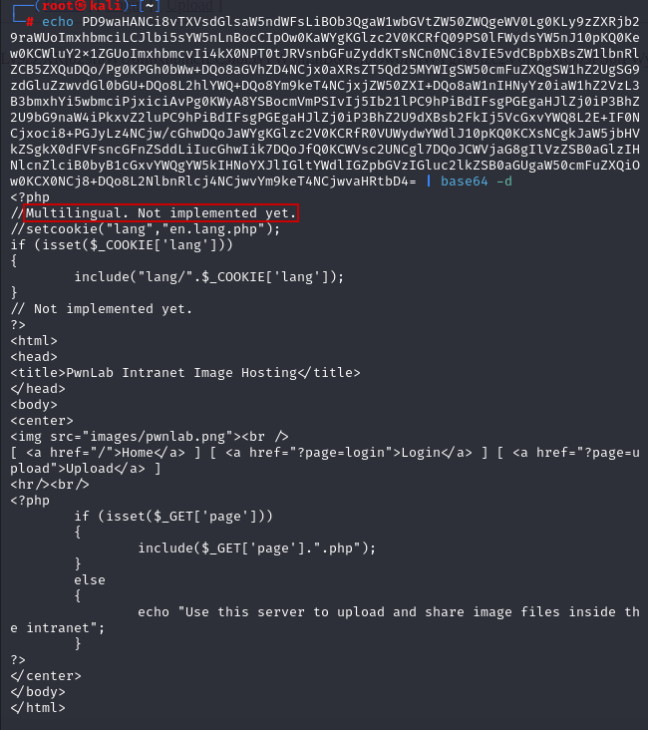

- Bypassing the upload.php filter
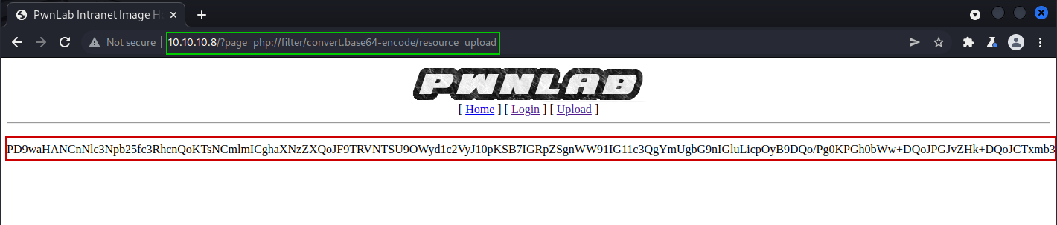

- Decoded base-64 content
- Can see that various allowed file types including .gif and .png
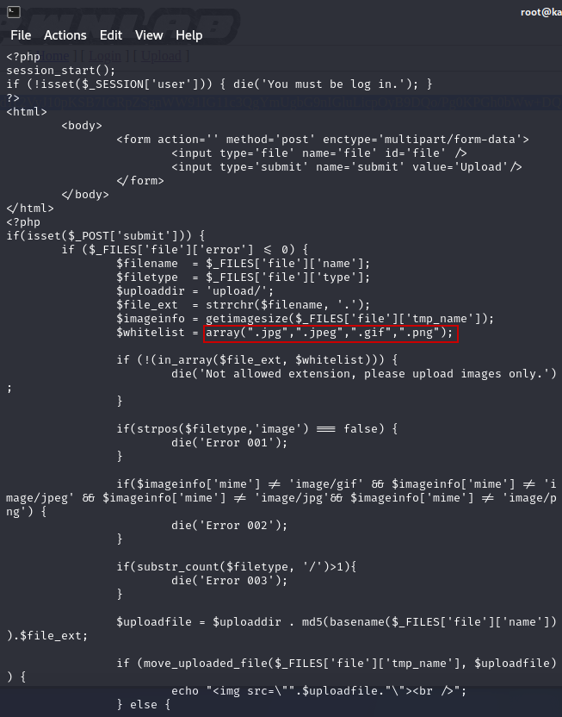
- Use newfound password from /config php, through remote execution
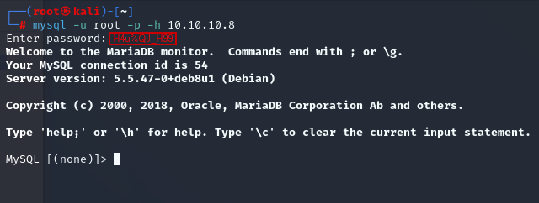

- Enumerate through MySQL to find users and encoded passwords
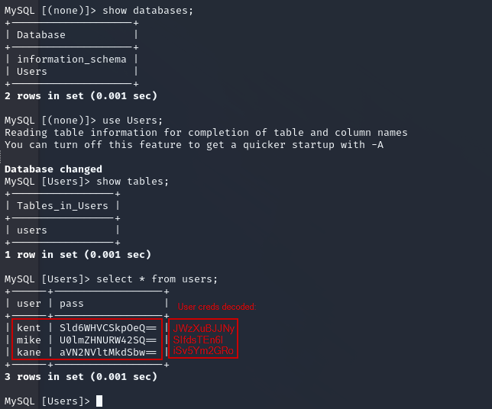

- Use credentials to gain access to be able to upload files
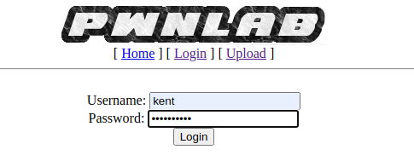
Gain access
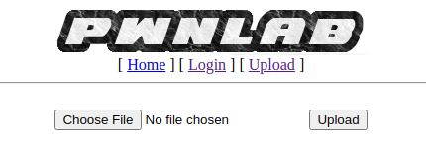

- Create a fake .png file with reverse shell php payload code inside, while also including a GIF header. This tricks pwnlab into letting the file through
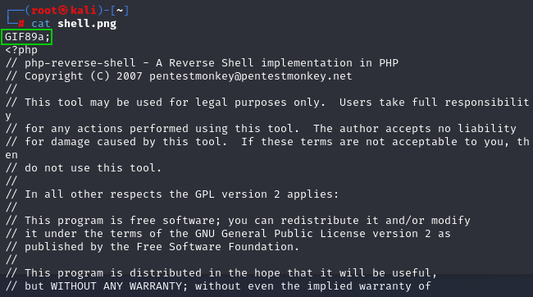

- Checking the /upload and the /upload/ pages shows it was a success
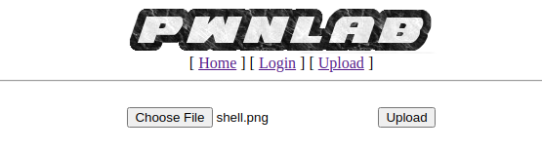
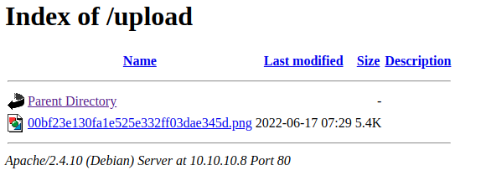

- Now we set up a listener on the 4444 port to get a shell
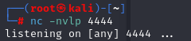

- Using BurpSuite, the cookie is changed to the .png file in order for the payload to execute
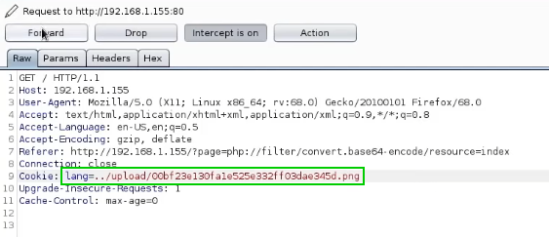

- A shell has been created
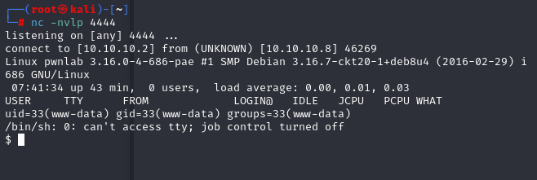

- Using python, a bash shell is spawned

- Confirm the users from the /etc/passwd file
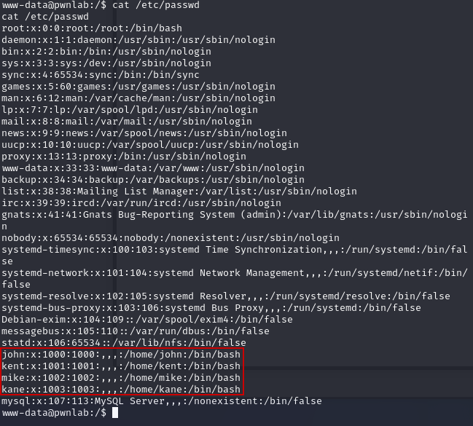

- Log into “kane” using the credentials we previously found
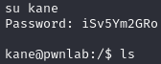

- Change to ~
- A “msgmike” file is here
- msgmike cannot be executed
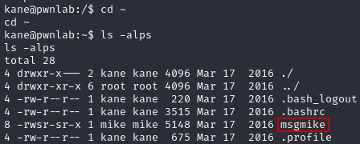

- By creating a script called “cat” and overriding the path variable we are able to get a shell for user mike
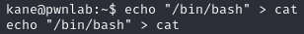
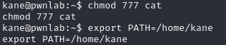

- Once we run msgmike, we get access to user mike, then the path variable must be reset
- Next we navigate to the /home/mike directory, there we find a msg2root file
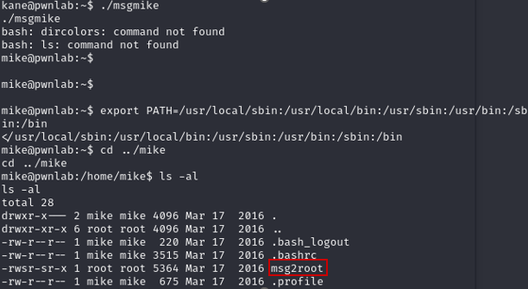
- Executing the file allows access to a root shell
- Navigating to find the flag.txt, the flag is found
